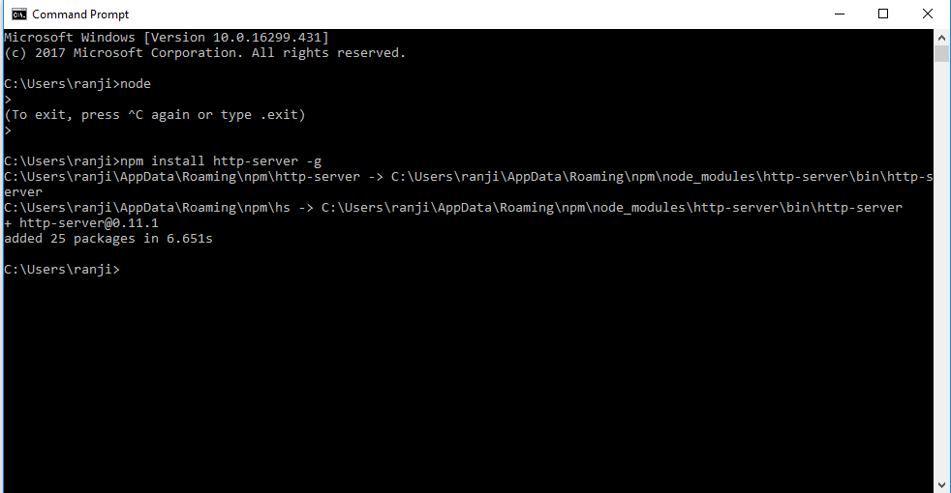

C:\Users\ranji\Desktop\MyWeb>npm init

This utility will walk you through creating a package.json file.

It only covers the most common items, and tries to guess sensible defaults.

See `npm help json` for definitive documentation on these fields

and exactly what they do.

Use `npm install <pkg>` afterwards to install a package and

save it as a dependency in the package.json file.

Press ^C at any time to quit.

package name: (myweb) RanjithAtWeb

Sorry, name can no longer contain capital letters.

package name: (myweb) mywebapp

version: (1.0.0)

description: This is my first web app

entry point: (server.js) server.js

test command:

git repository:

keywords: npm WARN init canceled

C:\Users\ranji\Desktop\MyWeb>npm init

This utility will walk you through creating a package.json file.

It only covers the most common items, and tries to guess sensible defaults.

See `npm help json` for definitive documentation on these fields

and exactly what they do.

Use `npm install <pkg>` afterwards to install a package and

save it as a dependency in the package.json file.

Press ^C at any time to quit.

package name: (myweb) MyWebApp

Sorry, name can no longer contain capital letters.

package name: (myweb) mywebapp

version: (1.0.0)

description: This is my first Web App

entry point: (server.js) server.js

test command:

git repository: https://github.com/Ranjithdss15/MyWebApp.git

keywords:

author: Ranjith

license: (ISC)

About to write to C:\Users\ranji\Desktop\MyWeb\package.json:

{

"name": "mywebapp",

"version": "1.0.0",

"description": "This is my first Web App",

"main": "server.js",

"dependencies": {

"express": "^4.16.3"

},

"devDependencies": {},

"scripts": {

"test": "echo \"Error: no test specified\" && exit 1",

"start": "node server.js"

},

"repository": {

"type": "git",

"url": "git+https://github.com/Ranjithdss15/MyWebApp.git"

},

"author": "Ranjith",

"license": "ISC",

"bugs": {

"url": "https://github.com/Ranjithdss15/MyWebApp/issues"

},

"homepage": "https://github.com/Ranjithdss15/MyWebApp#readme"

}

Is this ok? (yes) yes

C:\Users\ranji\Desktop\MyWeb>dir

Volume in drive C has no label.

Volume Serial Number is 88C8-3A46

Directory of C:\Users\ranji\Desktop\MyWeb

18-05-2018 15:39 <DIR> .

18-05-2018 15:39 <DIR> ..

18-05-2018 15:12 139 index.html

18-05-2018 15:23 <DIR> node_modules

18-05-2018 15:23 13,382 package-lock.json

18-05-2018 15:39 589 package.json

18-05-2018 15:27 212 server.js

4 File(s) 14,322 bytes

3 Dir(s) 36,364,324,864 bytes free

C:\Users\ranji\Desktop\MyWeb>node server.js

C:\Users\ranji\Desktop\MyWeb>npm install --save express-handlebars

+ express-handlebars@3.0.0

added 43 packages in 12.906s

C:\Users\ranji\Desktop\MyWeb>node server.js

C:\Users\ranji\Desktop\MyWeb>node server.js

Express Started